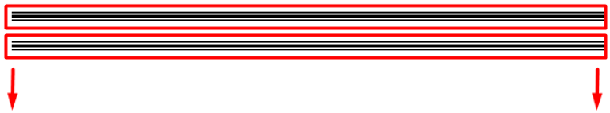 5

ازى اعرض كل المنتجات فى صفحه وحده

اول حاجه محتاج اعمل route واسميه مثلا وليكون all_products

واقلو انت ترترنلى على صفحه معاينه وليكون صفحه اسميها page_show_all_products

اعمل ال route الى هرمى عليه الصفحه :)

Route::get('show/all/products','Hompagefrontend@show_all_products_page');

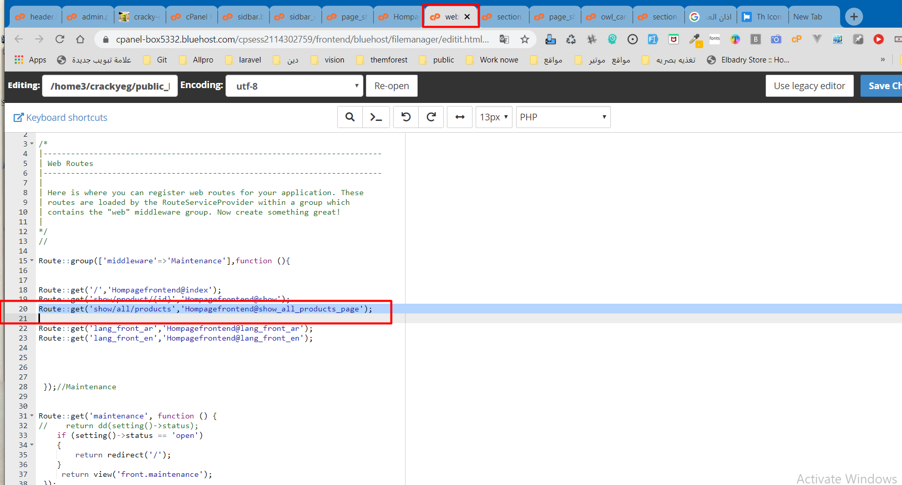

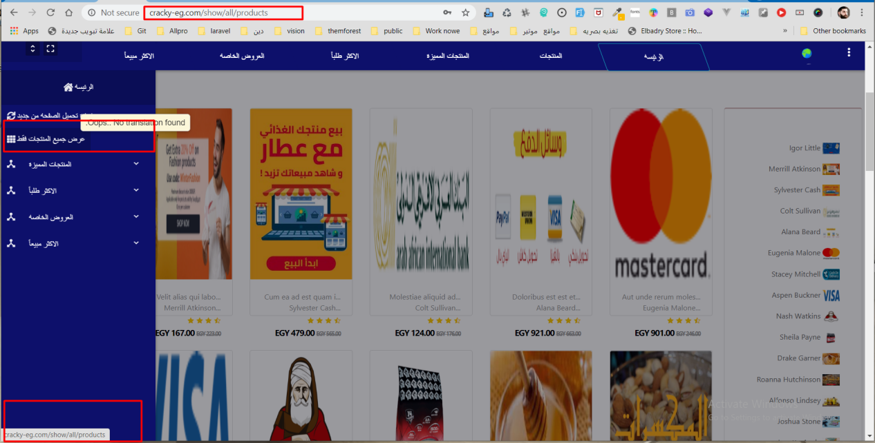

2

ه فى صفحه ال controller

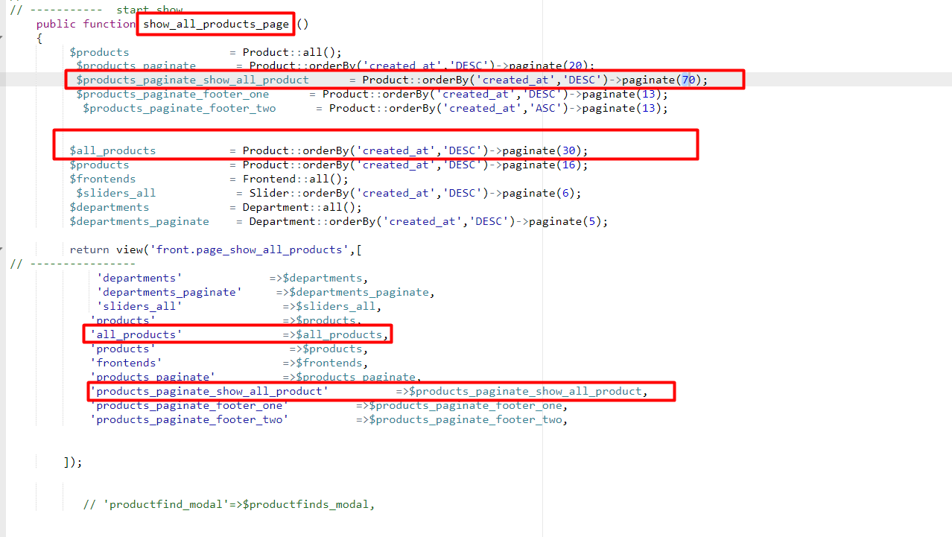

// ----------- *start show* public function show_all_products_page ()  
 {  
 $products = Product::*all*();  
 $products_paginate = Product::*orderBy*('created_at','DESC')->paginate(20);  
 $products_paginate_show_all_product = Product::*orderBy*('created_at','DESC')->paginate(70);  
 $products_paginate_footer_one = Product::*orderBy*('created_at','DESC')->paginate(13);  
 $products_paginate_footer_two = Product::*orderBy*('created_at','ASC')->paginate(13);  
  
  
 $all_products = Product::*orderBy*('created_at','DESC')->paginate(30);  
 $products = Product::*orderBy*('created_at','DESC')->paginate(16);  
 $frontends = Frontend::*all*();  
 $sliders_all = Slider::*orderBy*('created_at','DESC')->paginate(6);  
 $departments = Department::*all*();  
 $departments_paginate = Department::*orderBy*('created_at','DESC')->paginate(5);  
  
 return view('front.page_show_all_products',[  
// ----------------  
 'departments' =>$departments,  
 'departments_paginate' =>$departments_paginate,  
 'sliders_all' =>$sliders_all,  
 'products' =>$products,  
 'all_products' =>$all_products,  
 'products' =>$products,  
 'frontends' =>$frontends,  
 'products_paginate' =>$products_paginate,  
 'products_paginate_show_all_product' =>$products_paginate_show_all_product,  
 'products_paginate_footer_one' =>$products_paginate_footer_one,  
 'products_paginate_footer_two' =>$products_paginate_footer_two,  
  
  
 ]);  
  
  
 // 'productfind_modal'=>$productfinds_modal,

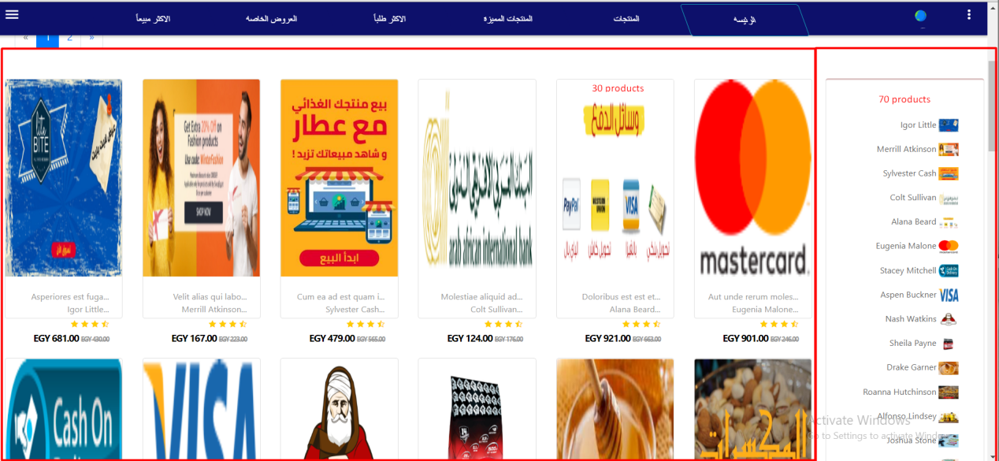

وكررتهم مرتين عشان انا محتاج مره عداد المنتجات يكون 30 عشان اعرض المنتج كله ...والمره التانيه 70 عشان اعرض اسماء فقط

وده طبعال اكود لحمد ما اظبط محرار الاكود عشان التنسيق

@include('front.layout._include.header')  
  
  
@php  
if (empty (session('lingfront')))  
{  
$lang ='ar';  
}else{  
$lang = session('lingfront');  
}  
@endphp  
@include('front.layout._include.sidbar')  
<!------------------------------------------------------->  
<section class="m_20_0 wow fadeInLeft m_t_b30px " data-wow-duration="3s" data-wow-delay="1s" data-wow-iteration="1" style=" ">  
 <div class="container-fluid p_0_0" style="padding: 0;">  
 <div class="row content_larg_img">  
 <div class="col-md-12" style="height: 300px**!important**;">  
 <a href="#">  
 <img class="w_100_100 h_300_px img_larg_dep" src="http://cracky-eg.com/public/storage/frontends/sYeWdukW8uUQzfBTSgASED1FbqfobtuiIFQsgwtF.png">  
 <img class="" src="{{url('default')}}/dep.png" class="w_h_px" style="width: 20px;height: 20px;" >  
 </a>  
 </div><!--/.col-md-12-->  
 </div><!--End row-->  
 </div><!--End container-->  
</section><!--End section-->  
  
<!------------------------------------------------------->  
  
<section class="">  
  
 <!------------------------------------------------------->  
 <section class=" " >  
 <div class="container-fluid " >  
 <div class="row content_flex ">  
 <div class="col-md-10 box_one " >  
 @include('front.layout._include.all_product')  
 </div><!--/.col-md-10-->  
 <div class="col-md-2 content_sidbar_name_products box_two" >  
 <!------------------------------------------------>  
  
 <div class=" wow fadeInRight box_one d-none d-md-block d-lg-block" data-wow-duration="2s" >  
 <section class=" " >  
 <div class="card card_product_details " >  
 <div class="card-body ">  
  
  
 <!-- ================================================================================== -->  
 <ul class="list-group list_group_links_dpe list-group-flush text-right m_t_b30px ">  
 @foreach($products_paginate_show_all_product as $product_paginate_show_all_product)  
 <li class="list-group-item"><a href="{{$product_paginate_show_all_product->id}} ">  
 <span> {{$product_paginate_show_all_product['product_name_'.$lang]}} </span>  
 <span> <img class="w_30_hpx_20px" src="{{url('public/storage').'/'.$product_paginate_show_all_product->photo}}"> </span>  
 </a></li>  
 @endforeach  
 {{$products_paginate_show_all_product->links('vendor.pagination.bootstrap-4')}}  
 </ul>  
 <!-- ================================================================================== -->  
 </div><!--card-body-->  
 </div><!--card-->  
 </section><!--content_col_2-->  
  
  
  
 </div><!--col-md-2 further_info-->  
 <!-- ============================================================End section new_product -->  
 <style type="text/css">  
 .card_product_details{  
 border-top-left-radius: 4px;  
 border-top-right-radius: 4px;  
 border-top: 2px solid #d9bebe;  
  
 }  
 .card_product_details_body.card-body{  
 padding: 3px 0;  
 }  
 .list_group_links_dpe li a {  
  
 display: block;  
 font-size: 13px;  
 color: #666;  
 padding: 8px 18px;  
 transition:all .5s ease;  
 }  
 .list_group_links_dpe li {  
 border:none;  
 padding: 0px 0px;  
 }  
 .list_group_links_dpe li a:hover {  
 color: blue;  
 padding-right: 30px;  
 font-size: 14px;  
 background: #d9bebe  
 }  
 .container  
 {  
 max-width: 1300px;  
 }  
 </style>  
 <!------------------------------------------------>  
 </div><!--/.col-md-2-->  
 </div><!--End row-->  
 </div><!--End container-->  
 </section><!--End section-->  
  
 <!------------------------------------------------------->  
</section><!--./ content_flex-->  
@include('front.layout._include.btn_to_top')  
@include('front.layout._include.section_footer')  
  
@include('front.layout._include.footer')

